CDS Secure File Upload UI User Guide

Abstract

This document describes the process for uploading files to CDS via UI. It provides an overview of the business processes associated with the uploading of a file and sending a secure message, as well as the details of the UI endpoint and message structures.

Origin / Author: CDS Digital API Team
Date Issued: 05/01/2023
Status: Issued
Contents
1. Introduction 3
1.1. Scope of this Document 3
2. File Upload Service Overview 3
2.1. Background 3
2.2. Document Upload Process 4
2.2.1 Process Overview 4
2.2.2. Initiating an Upload and Documentary Controls 4
2.3 Two-way secure messaging 5
2.3.1 Process Overview 5
3. User Guide: Secure File Upload and Two-way Secure Message UI 6
3.1. Uploading a File 6
3.1.1 Landing Page 6
3.1.2 What do you want to do? 9
3.1.3 Movement Reference Number (MRN) 9
3.1.4 Contact Details 10
User contact details are retained in a session cache (TTL 60 mins). 10
3.1.5 File Upload 11
3.1.6 Successful Upload 13
3.2 Two-way secure messaging 15
3.2.1 Selecting message type 15
3.2.2 Using the secure inbox 16
3.2.3 Actions requested in the query message 18

Introduction

1.1. Scope of this Document
This document describes the steps required to send a document to CDS using the file upload UI endpoint on the Customs Declaration UI. In addition, it outlines the business processes associated with the file upload process to provide the user with an understanding of how this document is linked with declaration processing on CDS.
The File Upload API developer guide is out of scope for this document and is covered in its own Service Design document produced by the CDS programme here. The file is available in the CDS 03 – Customs Declaration Folder.
The intended audience is developers and CSPs who wish to integrate the HMRC UI into their service, to enable their customers to upload files to CDS.
Please note the UI is only available in Production and not in Trade Test or Trader Dress Rehearsal.

File Upload Service Overview

Background
Currently, CHIEF does not provide Traders with a service to digitally upload documentation to support the processing of Customs Import/Export Declarations. Traders provide supporting documentation via a multitude of channels and document mediums and HMRC National Clearance Hub (NCH) caseworkers currently manually receive and process documentation provided by declarants in support of submitted Customs declarations.
Under the Customs Declaration Service (CDS), HMRC has delivered the CDS Digital Secure File Upload Service to remove the need for the manual processing of supporting documentation for declarations submitted on CDS. The CDS Digital Secure File Upload Service allows the documentation uploaded in support of a declaration to be automatically transferred into HMRC’s case management solution for review.

Document Upload Process

2.2.1 Process Overview
As outlined in the Declaration Submission Service Design for Imports, the File Upload UI will enable a trader to upload a number of files for a given declaration ID (MRN) to a unique location (URL).
The UI will return a unique file reference code to the software for each file successfully submitted by the trader via a Digital notification. This file reference code can be used in future correspondence with HMRC.
The CDS system uses the MRN to link documents uploaded via the Secure File Upload Service and the original declaration. The Secure File Upload service can only be used to support CDS declarations (identified by MRN), and not CHIEF declarations. HMRC Caseworkers will be notified when each document uploaded by the trader is received, and also when all files uploaded together as a group for a declaration have been received. When all files have been received, HMRC Caseworkers will review the documents they contain against the case for the declaration ID (MRN) provided.
Please note that the submitter of the documents will not receive a confirmation notification from back-end CDS systems that confirm the file has been matched to the declaration.

The document files uploaded by the trader will be scanned for malware and then stored in HMRC’s document repository system where they will be retained in accordance with HMRC policies (7 years).

Initiating an Upload and Documentary Controls
An authenticated trader may use the service at any time to submit files containing their documents required to support the declarations made by them (this is only relevant to Frontier Declarations). It is not necessary to wait for an email or DMSDOC notification from HMRC.
In the event that further information is required in order to process a declaration, the NCH Caseworker will notify the trader of the fact that there is a query using secure messaging. The response to the query may include submission of further documents. Other departments and customs authorities using CDCM including Border Force can also raise their own cases and access secure messaging to contact the trader.
In some cases, a trader may have also received a DMSDOC notification triggered by the declaration risking process (Route 1 or Route 3) to submit their documents for a declaration that they have submitted.
It should be noted that the DMSDOC notification will not link to the Secure File Upload Service, nor will it specify the documents which must be uploaded. The same applies to CSP notifications and the Declaration Information API, both of which return the routing status for the declaration, but not which document(s) are required (see Section 1.3 References).
In the event of a documentary check, a declarant may choose to upload the particular document that is expected to have triggered the control (e.g. a licence document) or all documentation associated with the declaration.

Two-way secure messaging

2.3.1 Process Overview
The File Upload UI is now renamed with service name ‘CDS document uploads and secure messages’ on the service header. It incorporates a secure inbox which can be used by CDCM case management system. Case workers from NCH, Border Force and Office for Product Safety and Standards (OPSS) can use this secure message service to raise a query on documents or goods in Documentary Control or Physical Control.
Replies to secure messages trigger the service level agreement case timer on CDCM.
Users can reply once or multiple times to messages. They can also divert into the file upload service to send documents required for a particular declaration. The messages are identified by MRN and case number, and by the authority name of the sender of the message.

User Guide: Secure File Upload and Two-way Secure Message UI
This section provides a detailed overview of the steps users should follow to obtain access to the Secure File upload UI, as well as screenshots demonstrating how to upload a file via the HMRC UI. The user will gain access to the CDS UI service via GOV.UK, using their Government Gateway registration credentials. Note, a valid EORI and subscription to CDS is a mandatory requirement.
Section 3.2 describes the steps to receiving and replying to secure messages from customs authorities, including screenshots demonstrating the user journey for this and the subsequent user journey to the file upload.
For declarations submitted using the API, the production URL for Integration is https://www.tax.service.gov.uk/cds-file-upload-service/start. This link will take the User to the landing page shown below.

3.1. Uploading a File

3.1.1 Landing Page
The user starts from GOV.UK https://www.gov.uk/guidance/send-documents-to-support-declarations-for-the-customs-declaration-service and a button to 'Start now'.
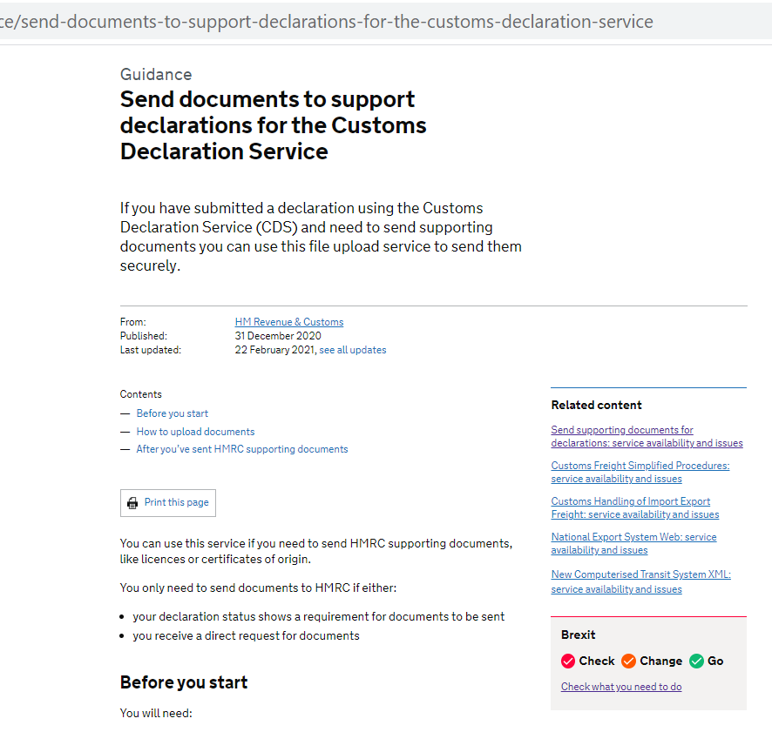
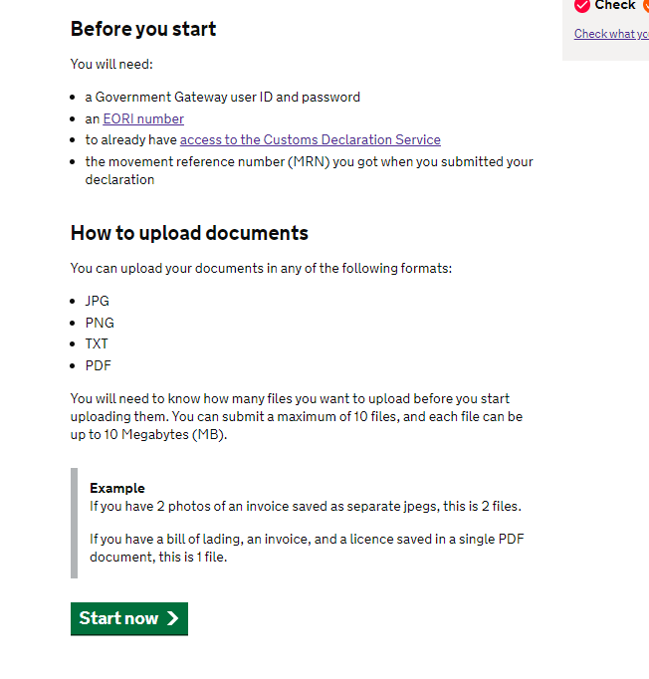

What do you want to do?
The user will first be offered to select to view messages about their declarations or attach documents to a declaration.
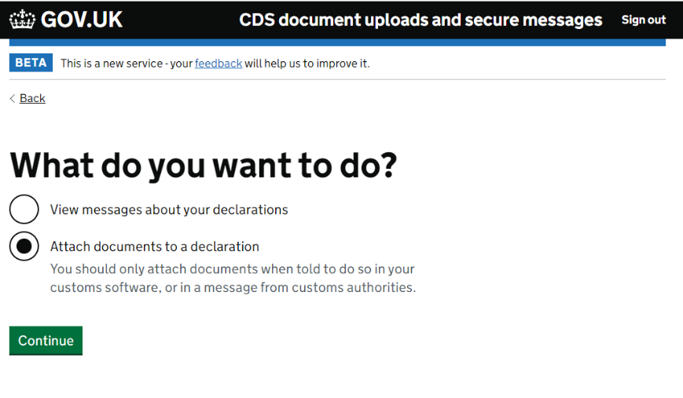

Movement Reference Number (MRN)
The user selects ‘Attach documents to a declaration’ and is then prompted to: Input Declaration MRN.

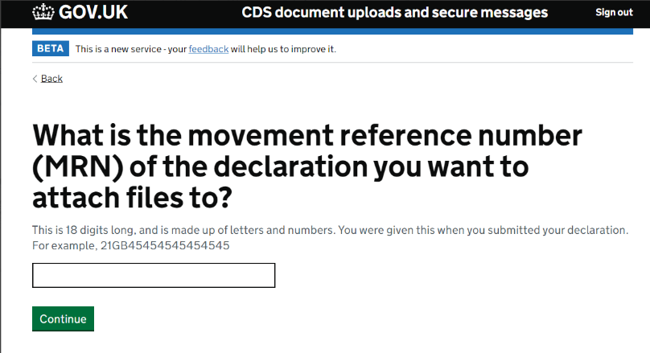

Note, the MRN is passed from the Declaration Information page on Export declarations submitted using Digital UI), or else manually type in the 18-characters Reference. Basic schema format validation is undertaken prior to allowing the user to continue to the next input page.

Contact Details
The user will then be prompted to: Input Contact Details
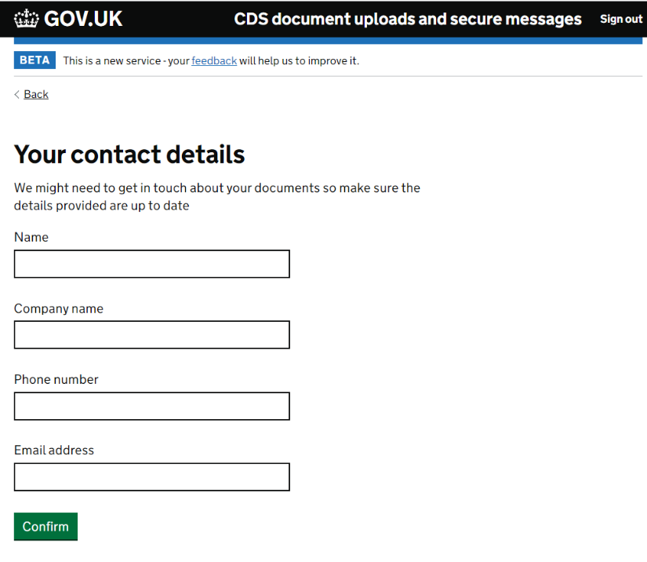
- Input Contact details (Name, Company Name, Phone Number & Email address).
- Note, the contact details entered are to assist NCH Case workers who will receive/process the uploaded documents.
- User contact details are retained in a session cache (TTL 60 mins).

3.1.5 File Upload
The user is then prompted to specify the number of files to upload. A maximum of 10 files can be submitted. Characters that have a specific usage in http should be avoided in the file names. For example %, ?, and & should be avoided because they are used as escape characters in http and so the service may behave unexpectedly when reading the filename. Tabs or special characters should be avoided.
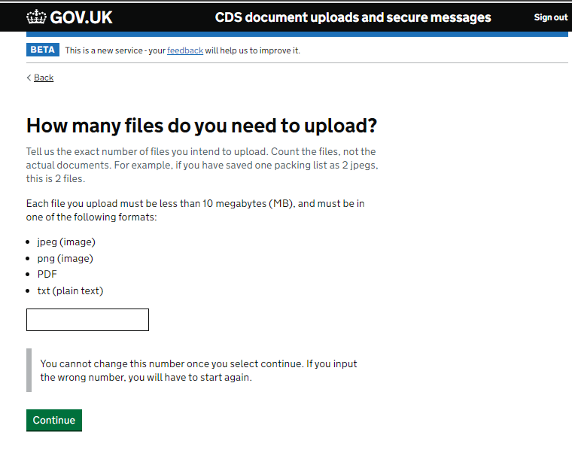

Choose files to be uploaded. Users will be able to upload multiple documents as a single file with a maximum file size of 10MB. Acceptable file formats are: jpeg, pdf, MS Word (.doc, .docx), MS Excel (.xls, .xlsx) or png.

Upload Document.

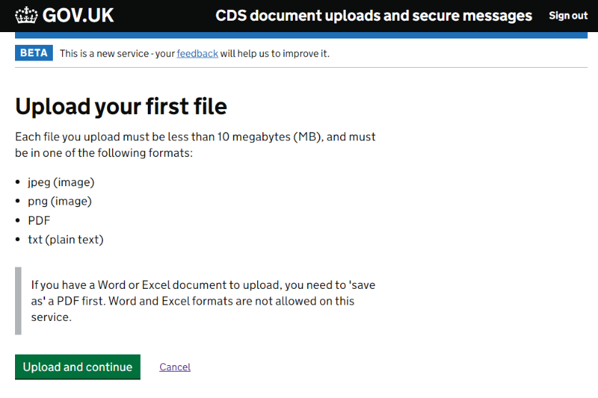

There is a reminder about how to convert Microsoft Word or Microsoft Excel to a PDF because these formats are not allowed.
If you have multiple files to upload and have specified this in the first screen of Section 3.1.5, you will be prompted to upload the next file in the following screen.

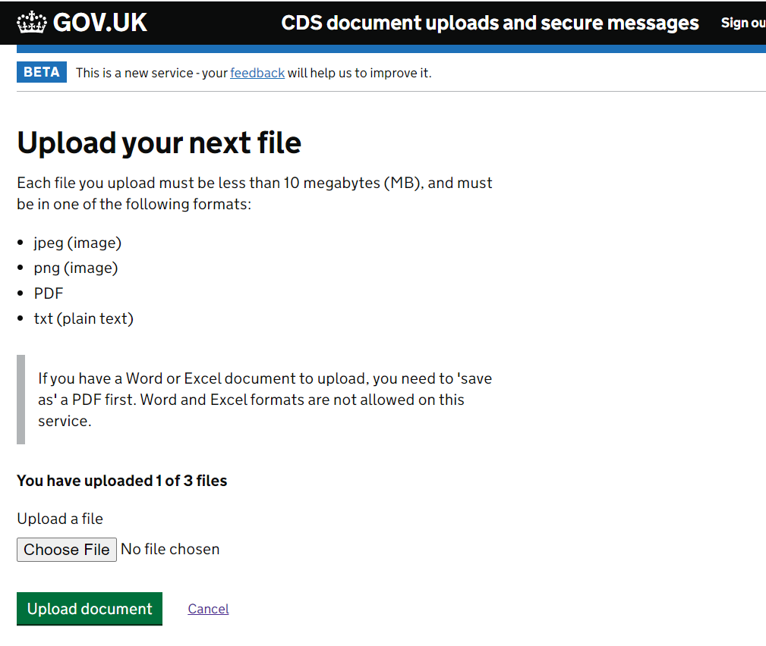

3.1.6 Successful Upload
Receipt of a Document Reference code confirms a successful file upload and replays the file names and reference numbers. The confirmation screen also advises users about possible queries – how and where they will be delivered. It advises on progress through customs control. This screen can be saved or printed. There is currently no email confirmation.
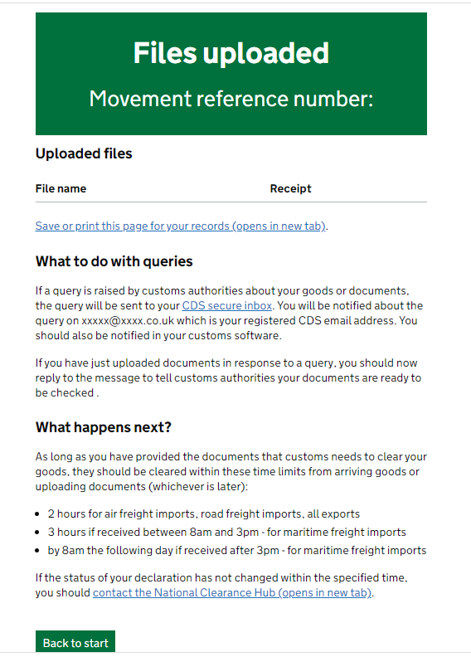

Where the SFUS Digital UI has been used, the user can leave the service by returning to the start page choices, or sign out from top header bar.

3.2 Two-way secure messaging

3.2.1 Selecting message type
Once the user has selected to view messages they then have to select the type of message they want to see from two options: exports messages and imports messages.
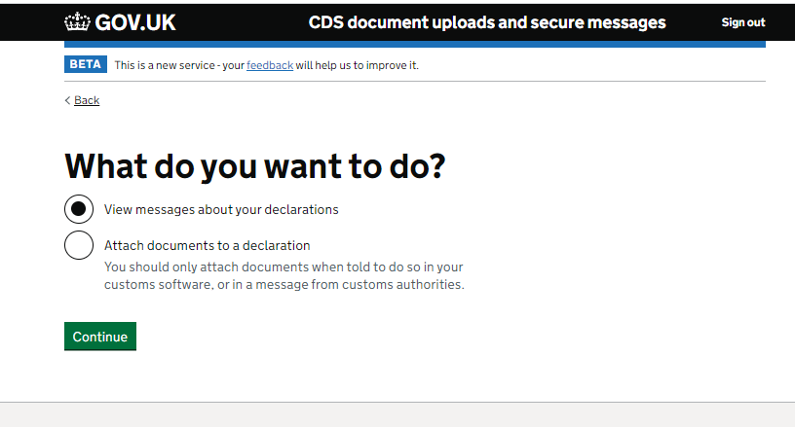
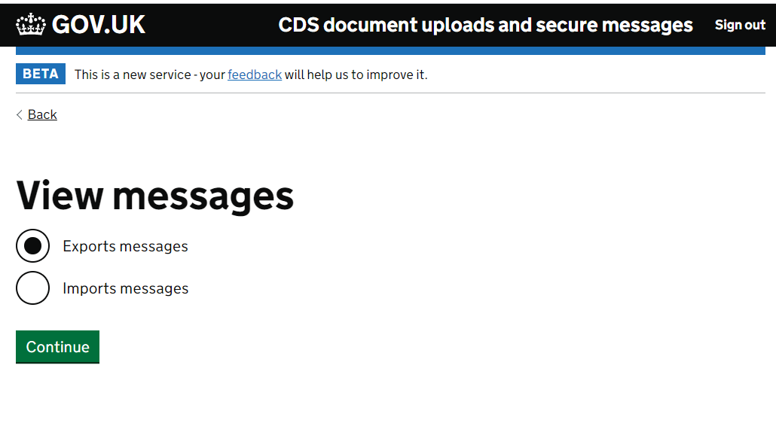

3.2.2 Using the secure inbox
The user’s secure inbox is a conversation by conversation view of messages, date and time stamped, with most recent message at the top.

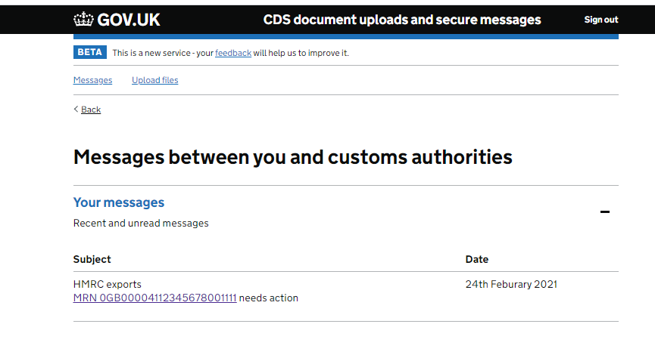
The user can open the thread, which will always be identifiable by the MRN in the subject line.

The body content of the message is the text written by the HMRC case worker on the CDCM system. Sometimes a reply-only action is all that is needed (e.g. no documents need to be uploaded).
If the user sends a message back to the customs agency using the messaging feature, they will get a confirmation page and a link back to the inbox they previously selected.

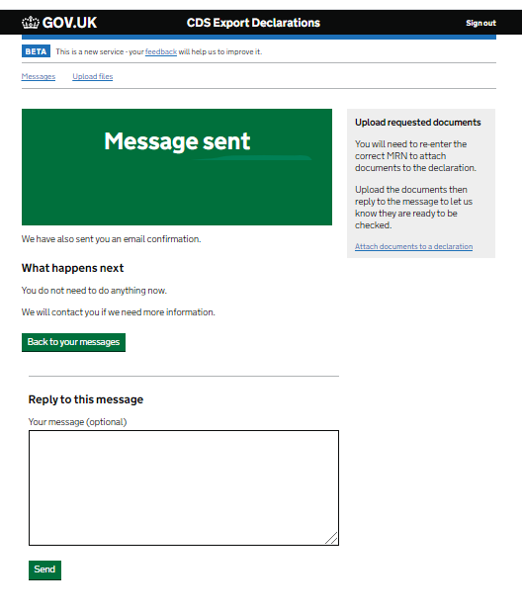

3.2.3 Actions requested in the query message
The query message may alert the user to actions such as to upload further documentation, amend a declaration, or take some action with another government agency. If the user has to use the upload feature, they must select the ‘Attach documents’ option at the right-hand side panel. This will take them to the MRN entry page and they can upload requested documents as described in Section 3.1 above. When they reach the upload confirmation page (as at Section 3.1.6 above) they will see a link to the inbox and a reminder to reply to the query message. Replying to the query message alerts the case worker that documents are ready to be checked, without this the declaration will not progress.

Document Control
Status:
Author | AO
Status | Baselined

Change Log:
Version | Date | Author | Comments
V0.1 | 01-10-2020 | CC | Initial Draft
V0.2 | 05-10-2020 | AO | Addition of sections 1-2, and inclusion of further details in section 3
V0.3 | 09-10-2020 | FR | Formatting and editing following JC comments.
V0.4 | 07-03-2021 | LH | Added query journey for secure messages and reflow of upload journey. New content throughout.
V0.41 | 24/03/2021 | CC | Update to secure messaging sections following document review
V0.42 | 17/05/2022 | PJ | Update to document location reference for the File Upload API Developer Guide
V0.43 | 24/11/2022 | TK | Added recommendation to section 3.1.5 File Upload, to advise submitters not to use % in their filenames.

OFFICIAL
© HM Revenue & Customs 2020.
All rights reserved.

